AUDITIONS FOR THE SERVANT (2)
Isaiah 45-48 (p.732)
Isaiah 1v1: Kings Uzziah – Hezekiah 740-700BC.
Isaiah 36: Sennacherib besieges Jerusalem 701BC
Babylon captures Jerusalem 597 & 587BC.
Cyrus the Great 559-530BC.
Cyrus takes Babylon 540BC.

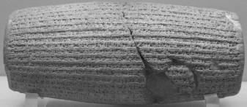

Introduction: If Israel has failed as the servant… has God failed too?

Surprise: Cyrus can be God’s servant

1) Only God can control the future

2) So only God can save

3) So rely only on God

Do discuss the talk afterwards and feel free to approach those leading or speaking with any questions arising from the meeting. In addition please use the Sunday Evening Question Box (under the balcony) if you have a question you’d like answered at the next question time.

